Operation Manual

Introduction
The following is comprehensive guide to the design, analysis, and manufacturing of a novel heat exchanger. This specific application is designed to pre-heat flowing hydrogen to temperatures of about 1000 K. The image below shows where the design will replace the existing geometry, which just served as a hydrogen supply tube and did not provide any heating.
Design Process
The design process is where models are generated in a CAD software so the geometry can easily be manipulated and parametrized. This is where creativity and engineering intuition come together to increase the performance of the design. For this application, temperature increase, and cross-sectional temperature distribution are the two performance parameters. Since the heat provided to the heat exchanger is on the outer surface, the heat will conduct through the outer surface into the flowing fluid, thereby heating the fluid. The following picture shows a cross sectional temperature distribution. **It is clear from the image that temperature distribution is not uniform. To produce a more uniform temperature distribution, a better geometry must be designed. The geometry is also usually constrained by several parameters. In this application, the design must not exceed 28 inches in length, and 2 inches in diameter. These variables must be considered when designing. This manual will be an overview of a simple heat cylindrical heat exchanger, but this process can be used for more complex geometries. As several CAD models are made to satisfy the performance parameters, their actual performance must be validated in some manner. This is where an analysis or testing process must be utilized.
Analysis Process
Testing is a costly procedure because it requires physical prototypes and exhaustive test procedures. Analysis through simulation tools allows for accurate prediction of the true performance of the design if the analysis correctly depicts the design’s environment. ANSYS is an excellent tool to perform fluid flow and heat transfer simulations and will be the tool used in this manual. The following will be typical steps involved in a multiphysics simulation, where fluid flow and heat transfer through a solid take place.
CAD
The first step is the importing of the geometry into ANSYS. This is done by selecting the Geometry box and importing a .STP file. The file can be opened by a built-in CAD program called ANSYS SpaceClaim. Here, a fluid extract is performed to turn the portion of the heat exchanger that is a fluid, into a solid, so it can be discretized into a mesh. Once the fluid is extracted, a meshing cell can be added to the geometry and ANSYS meshing is opened.
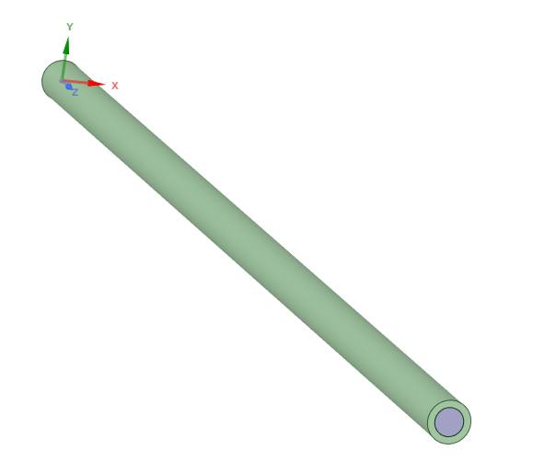
Mesh
Here, different meshing tools and settings can be used, depending on the application. In this application, a proximity mesh is used to refine the mesh at sharp corners or curved surfaces. An inflation layer is also used, which inserts finer mesh at the inner walls of the heat exchanger where the fluid touches so that the effects of the boundary layer formation can be examined. The rest of the mesh settings can be left as default and changed if the user desires. Named selections must be made for each surface of the geometry, as well as specifying the fluid domain and solid domains. Named selections make the process easier in the analysis setup so the user can refer to names like “Inlet” and “Outlet” instead of “Face 32” and “Face 24-1". After the mesh is created, an analysis setup cell can be added.
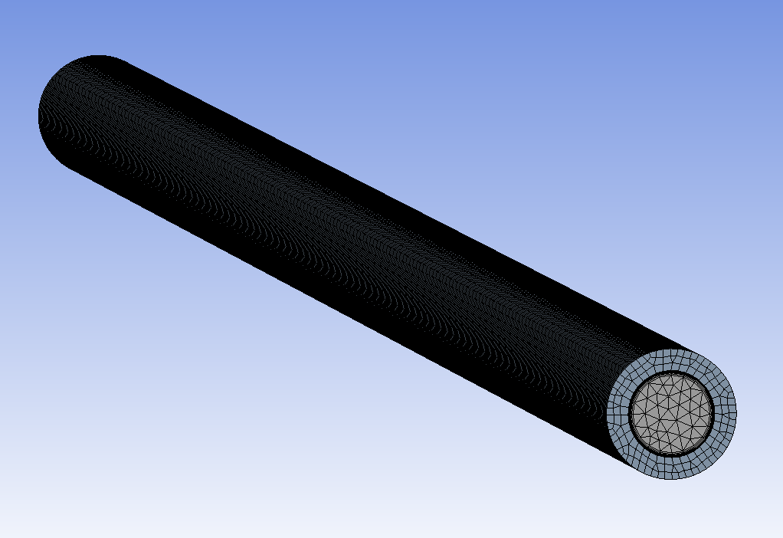
The image clearly shows a finer mesh where the boundary layer would form.
Setup
In the setup window, all the boundary conditions, material properties, and thermodynamic properties are inputted. The three boundary conditions in this problem are: 1000 psi inlet static pressure, 300 K inlet static temperature, and 10 g/s outlet mass flow rate. The fluid is hydrogen and the solid was chosen to be steel. In multi-physics analyses, a domain will show up as an interface. In this application it will be the fluid-solid interface. This just mean that ANSYS has recognized the interaction between two different materials and the user must specify what occurs at this interface. In this case heat transfer is all that is specified. After the physics of the problem are inputted, the solver settings are chosen. This process is highly dependent on the number of elements in the mesh, and the stability of the problem. These settings must be chosen very conservatively on the first analysis, and later refined to lower computational time. ANSYS has automatic settings called conservative auto timestep, which is usually a fine option for the first several runs. Once a user becomes more familiar with the problem, more aggressive timestep options can be specified. The next step to be able to monitor a simulation is to setup monitor variables to see their convergence history. For this application, outlet static and total temperature are important since the outlet static temperature is the main performance parameter of this analysis. Also, outlet static and total pressure are also monitored to ensure the simulation has completely converged. The image below shows a converged solution.

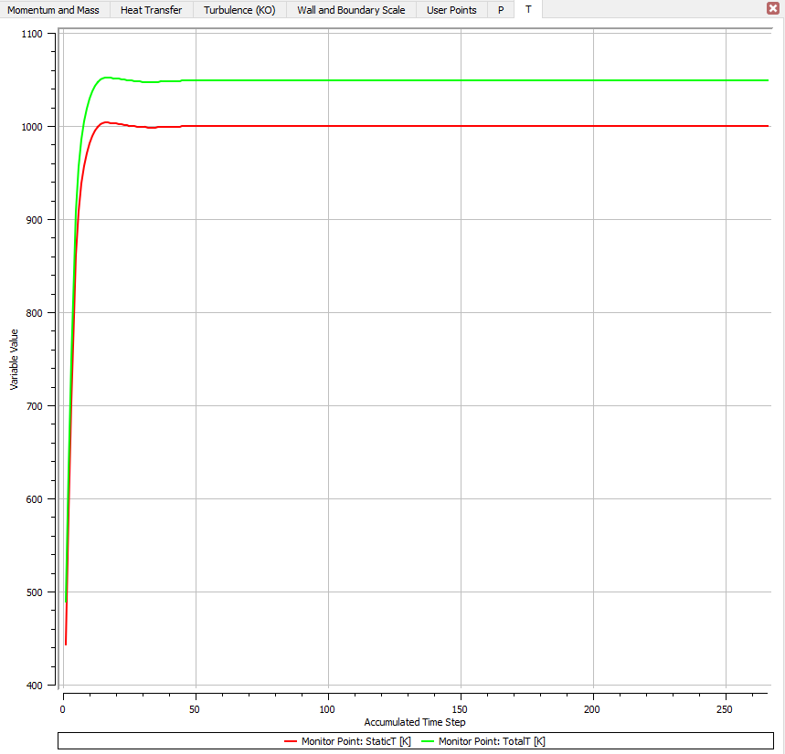

Post-processing
After a solution has converged, the results tab of the analysis cell can be selected. The results window will show the geometry and allow the user to visualize different thermodynamic properties such as pressure and temperature. Velocity vector plots and streamlines can also be created in post processing to get a better understanding of the flow physics. There are many different visualization tools in ANSYS post-processing. In this application, a plane is made parallel to the inlet and outlet surfaces so that different cross sections are exposed. Here contour plots are made from these planes and temperature is selected as the contour variable so that the temperature distribution can be seen. The image below shows temperature contours for multiple planes throughout the heat exchanger’s length. Velocity vector plots can also be made, so see the flow’s change in direction as it encounters changes in the geometry as it flows through the heat exchanger. Through this process, it was found that if flow were forced to flow into itself, it would mix the hotter and colder parts of the fluid and provide a more uniform temperature distribution.
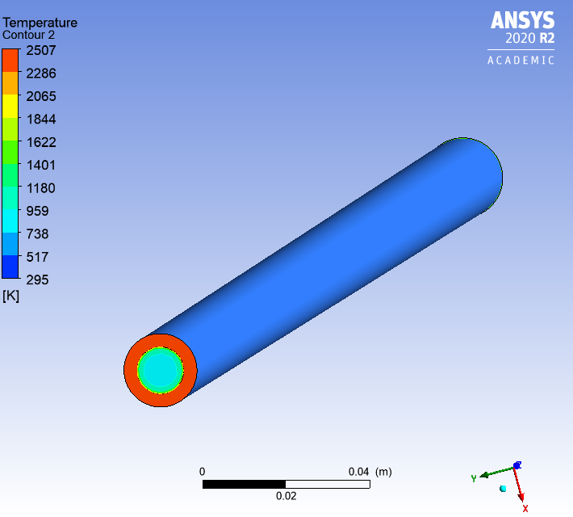
It is evident from post processing that the user can comment on design changes to improve the design based on the previous design’s performance. Solid temperatures are also an important step of the analysis because this will determine the temperatures seen on the surface of the heat exchanger and lead to material choices. Solid temperatures can be viewed by making cross sectional planes and selecting temperature as the contour like previously done.
Manufacturability/material choice process
When the maximum solid temperatures are known, a choice can be made for the material choice of the heat exchanger. This is no publicly available data for a margin of safety for melting temperatures of metals. A factor of safety of 1.5 will be chosen. Since melting temperature is a bit different than stress, 1.5 is more than acceptable. The material choice will also play a role in the method of manufacture. For example, metals like tungsten are so strong that they cannot be machined from a billet and must be 3D printed. However, this is a costly process and can introduce unwanted defects. The designer must perform a cost-benefit analysis to determine the material choice and method of manufacture based on the solid temperatures, budget, and complexity of the geometric model. In this application, 3D printing by a firm called Beamler was used because the solid temperatures reached 2500K. NASA has the funds to 3D print tungsten, so this was an ideal choice. Finding a supplier and a manufacturer is important in this process.
Interfacing process
Interfacing to the existing system is paramount to the design. With a good design, it is worthless unless it can be installed smoothly without significant negative effects. In this case, the heat exchanger’s outlet was to be mounted to a flanged fitting, which can’t be viewed because the images are proprietary. However, the inlet was specified as a ½” male AN fitting. To mount to the male AN fitting, a Swagelok reducing fitting was first chosen to reduce the ¾" OD of the heat exchanger to a ½" OD. Then a coupling from ½” Swagelok to ½” female AN was chosen to mate to the first part. The three parts combined will provide an easy replacement of the original equipment. The following image shows the assembly.
Testing
When done correctly, analysis is a powerful tool. Although, there is always a possibility of unknown or unforeseen circumstances that could arise that may not be accounted for in the analysis. The next step of implementation would be to test the unit with the provided 100 kW power supply. This would validate the analysis with actual results. If the test results are significantly different than the analysis results, it shows that further fine tuning is required. If the results are accurate, and test results and analysis results are close, this shows that the analysis is defined correctly, and the foundation can be used for different types of heat exchangers. If it is decided in the future that the customer needs different characteristics from a heat exchanger, the groundwork will be done, and be validated with test results.
Note:
NASA (National Aeronautics and Space Administration) performs these tests and does not publish the information, as it is proprietary. The designer must assume the lab technicians can perform the installation of the pre-heater and install the induction coils around the heat exchanger. The lab technician will ensure the bolts of the flange are torqued to specification. The lab technician will also tighten both Swagelok fittings to specification. The test will involve opening the hydrogen supply valve and increasing the power of the induction coils until it is at 100kW. NASA has pyrometers to measure the outlet temperature of the pre-heater to validate results.

